

# Assignment JS Beginnings

Each question is 5 marks

Answer each question in your own words (No copy paste):

1. Explain variables in JavaScript.
2. What is the difference between let, var and const?
3. What are the two ways we learned to output data in JavaScript?
4. Explain what a template literal is.
5. Explain why 5 !== "5" is true.
6. Explain the anatomy of an if statement in JavaScript?
7. What is a loosely typed language?
8. Why wont the code in the image below reach line 5?

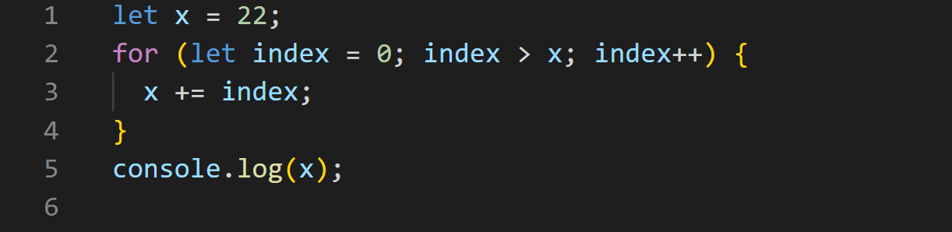

1. What does "++" mean and why is it useful?

Solve the problem:

1. Make two variables (Call them A and B) write a JavaScript program that outputs the values as a string

Case 1)

Inputs = 12, 3

Output = "12 + 3 = 15", "12 - 3 = 9", "12 x 3 = 36", "12 / 3 = 4"

11. Using inputs, template literals and variables, make a program that takes in a first name, last name, age, and occupation and prints out the data in a fluent sentence

Case1)

Input = Jeff, Bezos, 58, Business owner

Output = Hi! My name is Jeff Bezos, I am 58 and I am a business owner.

Next Page>>

12. Using inputs/outputs, variables, and if statements, write a program that takes in two integers (A and B) and prints the following:

When both A and B are odd, print their product(multiplication) (A*B)

When both A and B are even, print their quotient (division) (A/B)

When A is odd and B is even, print their (sum) (addition)(A+B)

When A is even and B is odd, print their difference (subtraction)(A-B)

Case 1)

Input = 5, 7

Output = 35

Case 2)

Input = 12, 2

Output = 6

Case 3)

Input = 5, 6

Output = 11

Case 4)

Input = 12, 3

Output = 9

13. Using inputs/outputs, variables, template literals, and loops write a program that takes in a user input and prints, all the numbers from 1 – 100 while multiplying the user input by the current loop counter:

Input = 3

Output (as a string) =

“3 x 1 = 3”

“3 x 2 = 6”

“3 x 3 = 9”

“3 x 4 = 12”

... this will repeat till you get to

“3 x 99 = 297”

“3 x 100 = 300”

True and False (Feel free to explain if you are uncertain):

14. JavaScript is the same as Java.

15. In JavaScript you must define data type when creating a variable.

16. === doesn't check the data type.

17. What will this output: console.log((5 == "5" && !("a" == "A")) || 6 === "6")

Next Page>>

What is the output:

18. 

19. 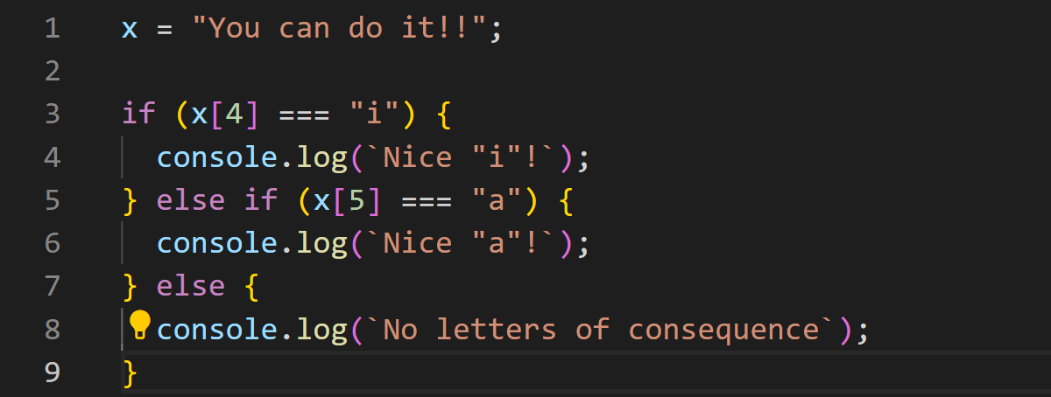

20. to clarify (1399 is the input)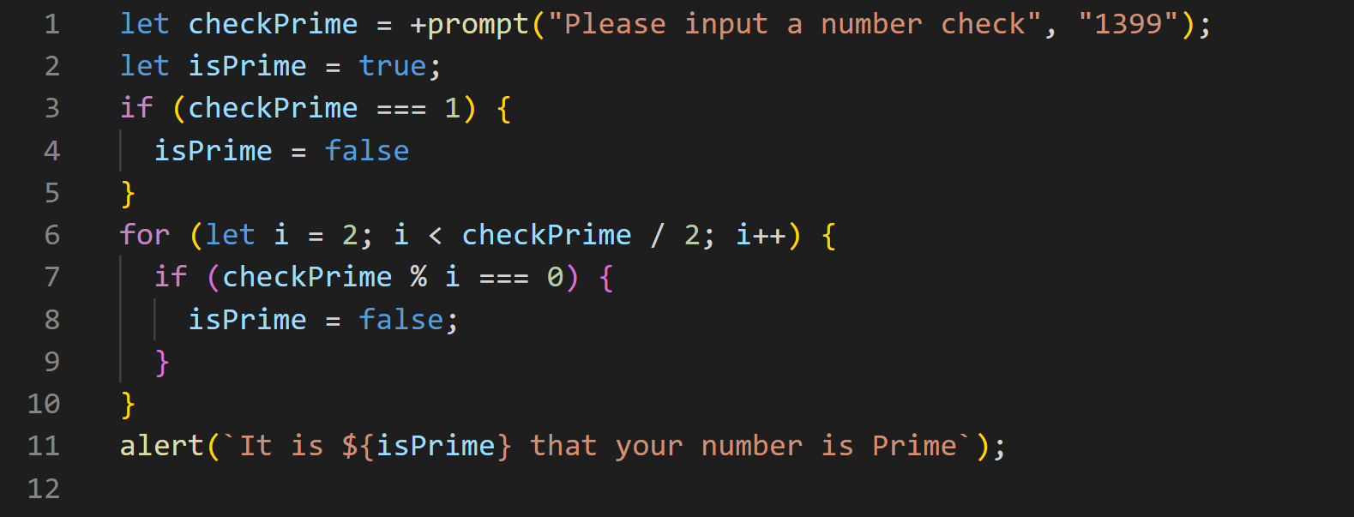

**End!**